CS 255 Business Requirements Document Nathan Perry

System Components and Design

Purpose
What is the purpose of this project? Who is the client and what do they want their system to be able to do?
- The purpose of this project is to design an online system for DriverPass, a company that provides driving test preparation services.
- DriverPass wants a system that offers online practice exams, on-the-road driving training scheduling, and progress tracking for students.
- The system must support multiple user roles, including students, instructors, administrators, and IT staff.
- The goal is to improve student pass rates by providing structured, up-to-date, and interactive training tools.

System Background
What does DriverPass want the system to do? What is the problem they want to fix? What are the different components needed for this system?
- DriverPass identified that over 65% of students fail their driving exams due to relying only on outdated test materials.
- There is currently no centralized system that combines practice tests, training scheduling, and performance tracking.
- The system must:
  - Deliver online practice exams aligned with current DMV standards
  - Allow scheduling of in-person driving lessons
  - Store and manage user data securely
- Key system components include:
  - Web-based user interface
  - Backend database for users, exams, and scheduling
  - Administrative management tools
  - Secure authentication and authorization mechanisms

Objectives and Goals
What should this system be able to do when it is completed? What measurable tasks need to be included in the system design to achieve this?
- Provide students with access to online practice exams that reflect current driving laws.
- Allow students to schedule, modify, and cancel driving lessons online.
- Enable instructors to manage lesson schedules and student progress.
- Allow administrators to manage users, content, and system settings.
- Improve student pass rates by tracking performance and identifying weak areas.
- Ensure system availability, reliability, and security.

Requirements

Nonfunctional Requirements

Performance Requirements
What environments (web-based, application, etc.) does this system need to run in? How fast should the system run? How often should the system be updated?
- The system shall be web-based and accessible through modern browsers.
- Pages shall load within 2–3 seconds under normal operating conditions.
- The system shall support multiple concurrent users without performance degradation.
- Practice exam content shall be updated as driving laws change.
- The system shall be available 24/7, excluding scheduled maintenance.

Platform Constraints
What platforms (Windows, Unix, etc.) should the system run on? Does the back end require any tools, such as a database, to support this application?
- The system shall operate on Windows and macOS platforms via a web browser.
- The backend shall use a relational database to store user and system data.
- The system shall be hosted on a cloud-based environment for scalability.
- No client-side software installation shall be required.

Accuracy and Precision
How will you distinguish between different users? Is the input case-sensitive? When should the system inform the admin of a problem?
- Each user shall have a unique login credential.
- User input shall be validated to prevent incorrect or incomplete data submission.
- The system shall log and notify administrators of critical system errors.
- Practice exam scoring shall be calculated and stored accurately.
- User actions shall be time-stamped for auditing purposes.

Adaptability
Can you make changes to the user (add/remove/modify) without changing code? How will the system adapt to platform updates? What type of access does the IT admin need?
- Administrators shall be able to add, modify, or remove users without code changes.
- The system shall allow updates to practice exam content without system downtime.
- The system shall adapt to browser and operating system updates.
- IT administrators shall have elevated access for system maintenance and monitoring.

Security
What is required for the user to log in? How can you secure the connection or the data exchange between the client and the server? What should happen to the account if there is a “brute force” hacking attempt? What happens if the user forgets their password?
- Users shall authenticate using a username and password.
- Passwords shall be encrypted and stored securely.
- The system shall use HTTPS to secure data transmission.
- Accounts shall lock temporarily after multiple failed login attempts.
- Users shall be able to reset passwords using a secure recovery process.
- Role-based access control shall restrict functionality by user type.

Functional Requirements
Using the information from the scenario, think about the different functions the system needs to provide. Each of your bullets should start with “The system shall . . .” For example, one functional requirement might be, “The system shall validate user credentials when logging in.”
- The system shall allow users to create and manage accounts.
- The system shall authenticate users based on role (student, instructor, admin).
- The system shall provide online practice driving exams.
- The system shall score exams and provide immediate feedback.
- The system shall track student progress and exam history.
- The system shall allow students to schedule driving lessons.
- The system shall allow instructors to manage lesson availability.
- The system shall allow administrators to manage users and system content.
- The system shall generate reports for administrative review.

User Interface
What are the needs of the interface? Who are the different users for this interface? What will each user need to be able to do through the interface? How will the user interact with the interface (mobile, browser, etc.)?
- The system shall provide a web-based interface accessible via browser.
- Students shall be able to:
- Take practice exams
- View scores and progress
- Schedule driving lessons
- Instructors shall be able to:
- View assigned students
- Manage schedules
- Record lesson outcomes
- Administrators shall be able to:
- Manage users and roles
- Update exam content
- View system reports
- The interface shall be intuitive and accessible to users with basic computer skills.

Assumptions
What things were not specifically addressed in your design above? What assumptions are you making in your design about the users or the technology they have?
- Users have access to a reliable internet connection.
- Users have basic familiarity with web-based applications.
- Driving laws and exam requirements will continue to change over time.
- DriverPass will provide updated exam content when regulations change.
- The system will initially support English-only content.

Limitations
Any system you build will naturally have limitations. What limitations do you see in your system design? What limitations do you have as far as resources, time, budget, or technology?
- The system does not provide real-time vehicle tracking.
- Development time is limited by project deadlines.
- Budget constraints may limit advanced analytics features.
- The system relies on users to provide accurate information.
- Mobile app functionality is not included in the initial release.

Gantt Chart
Please include a screenshot of the GANTT chart that you created with Lucidchart. Be sure to check that it meets the plan described by the characters in the interview.

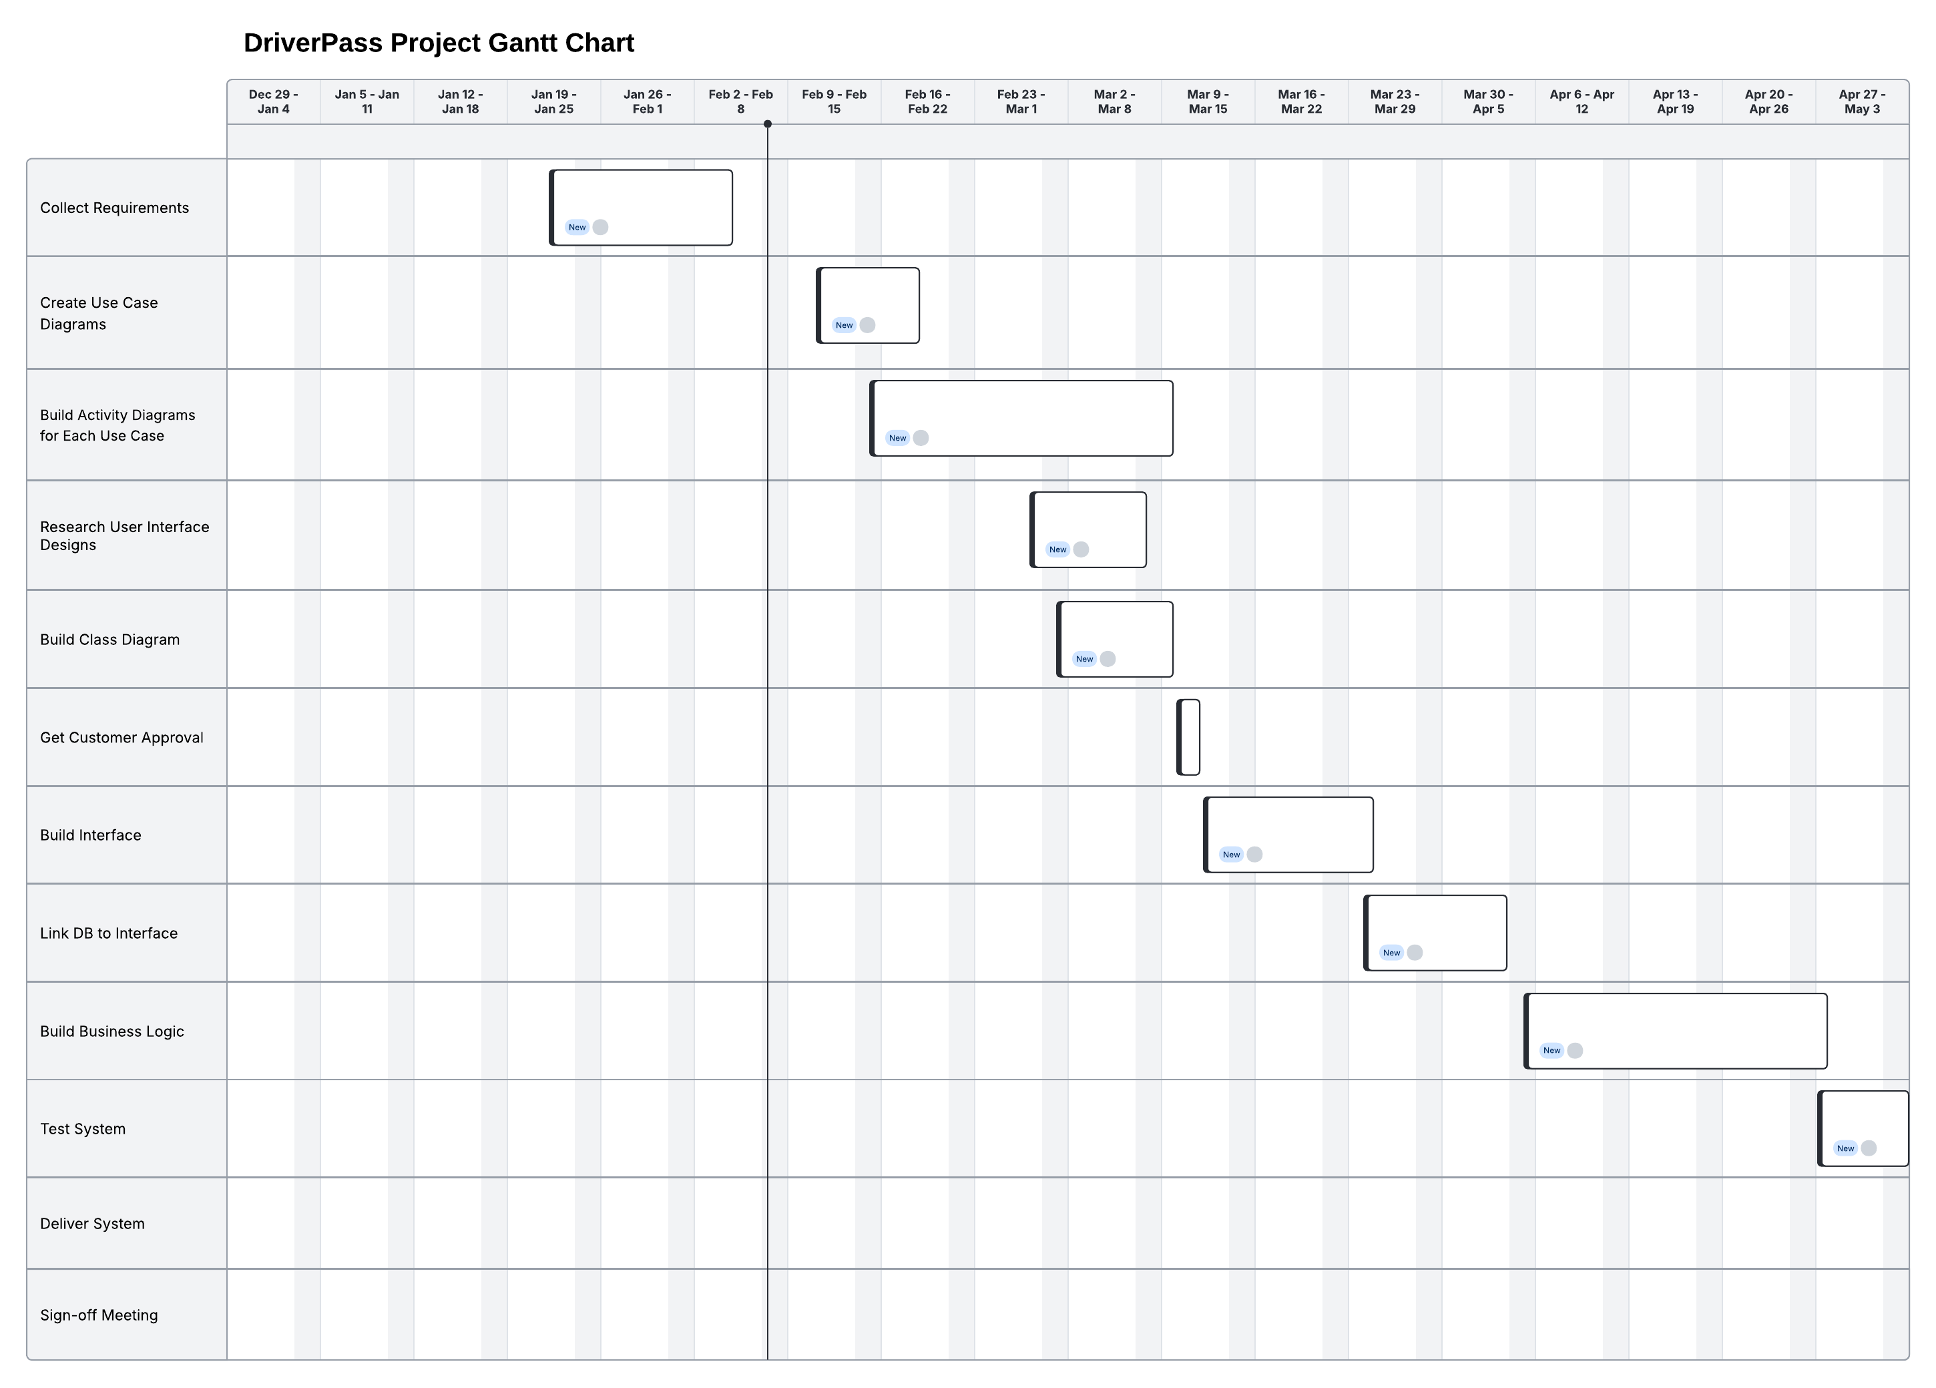

The chart includes:
- Requirements gathering
- System design
- Development
- Testing
- Deployment
- Training and documentation

